Day 35 API keys , authentication , environment variables and sending SMS

Rain Alert app to send SMS if it is going to rain today

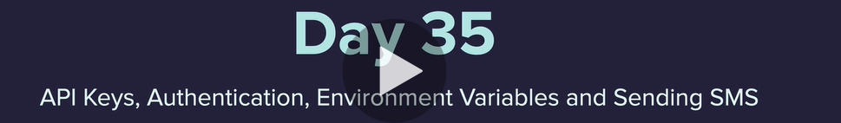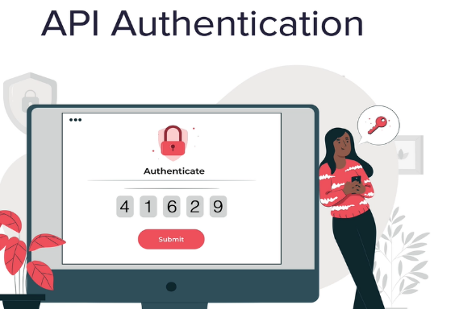



Some API’s need Keys

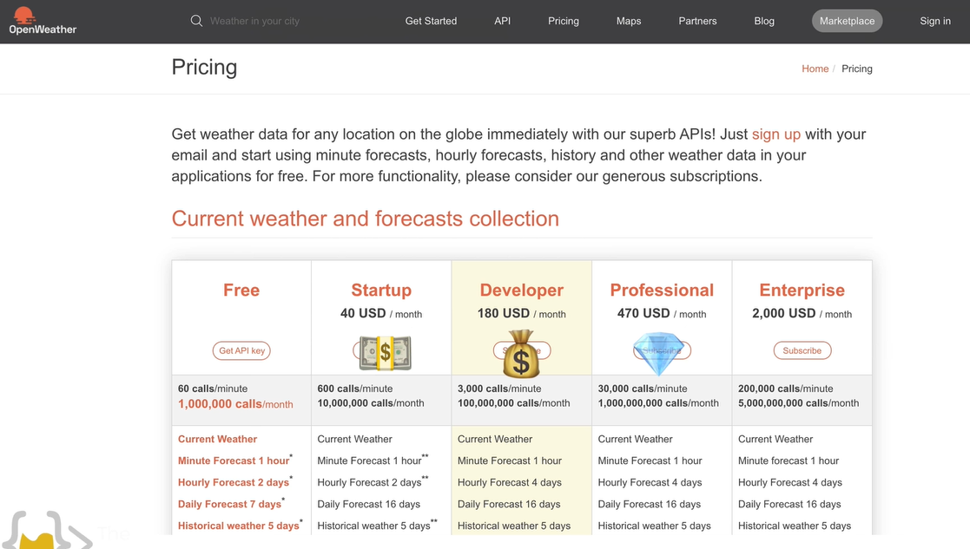

<https://home.openweathermap.org/users/sign_up>

email and cat

Open weather docs <https://openweathermap.org/current>

Online JSON viewer <http://jsonviewer.stack.hu/>

Lat and Lng finder <https://www.latlong.net/>

<https://openweathermap.org/api/one-call-api>

API Key passed into the url as a parameter

https://api.openweathermap.org/data/2.5/onecall?lat={lat}&lon={lon}&exclude={part}&appid=[{API key}](https://home.openweathermap.org/api_keys)

<https://api.openweathermap.org/data/2.5/onecall?lat=39.729431&lon=-104.831917&exclude=current,minutely,daily,alerts&appid=>

Hourly forcast for next 48 hours from the json object

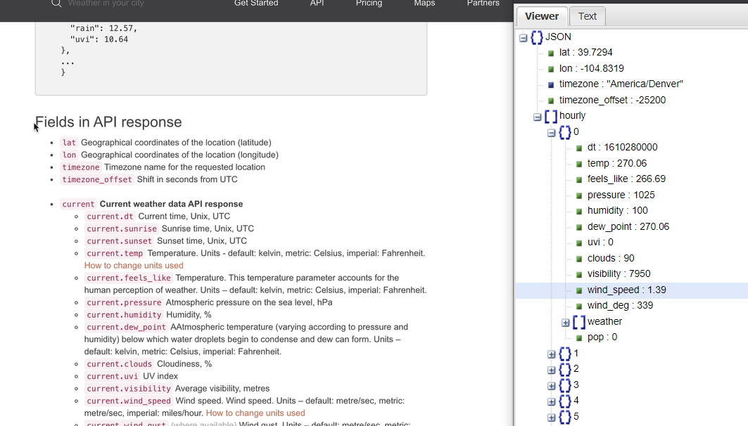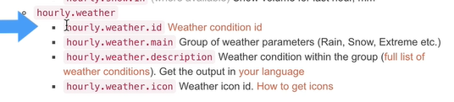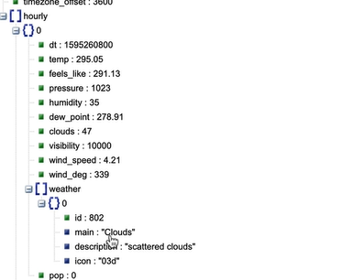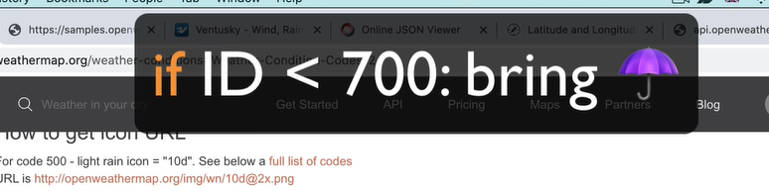

Find a place where it is raining <https://www.ventusky.com/>

Python slice <https://www.w3schools.com/python/ref_func_slice.asp>

Slice notation <https://stackoverflow.com/questions/509211/understanding-slice-notation>

Twillio <https://www.twilio.com/try-twilio>

Twillow for python anywhere <https://help.pythonanywhere.com/pages/TwilioBehindTheProxy/>

Python anywhere <https://help.pythonanywhere.com/pages/TwilioBehindTheProxy/>

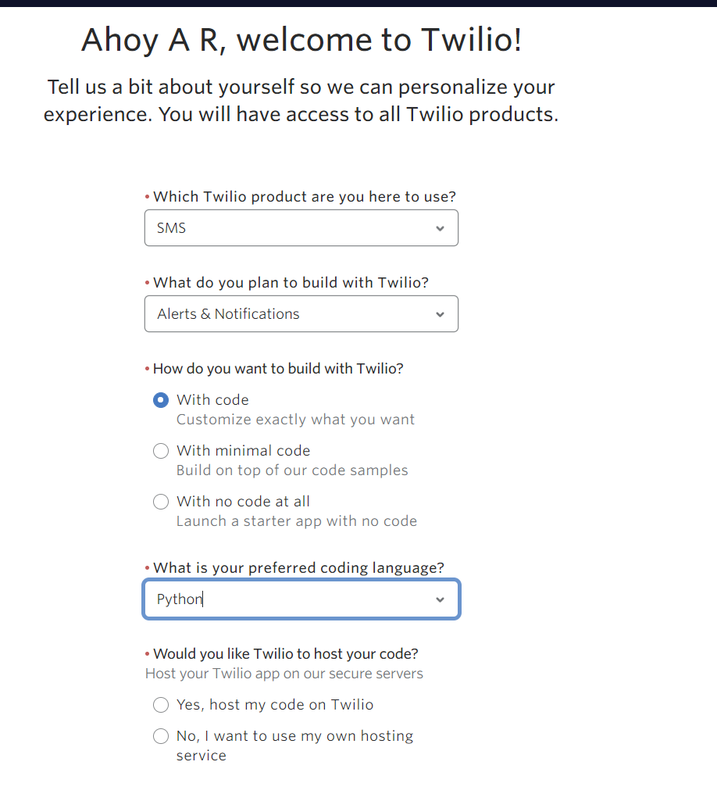

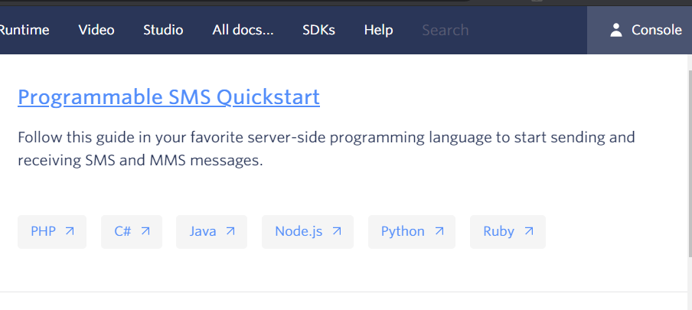

Python anywhere lecture

<https://www.udemy.com/course/100-days-of-code/learn/lecture/21326812#questions/13720212>

environment variables

<https://en.wikipedia.org/wiki/Environment_variable>

source of API’s

https://apilist.fun/

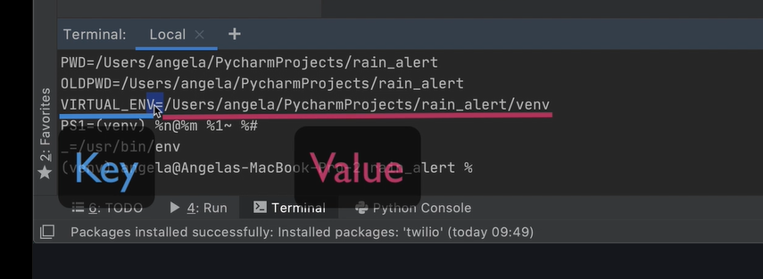

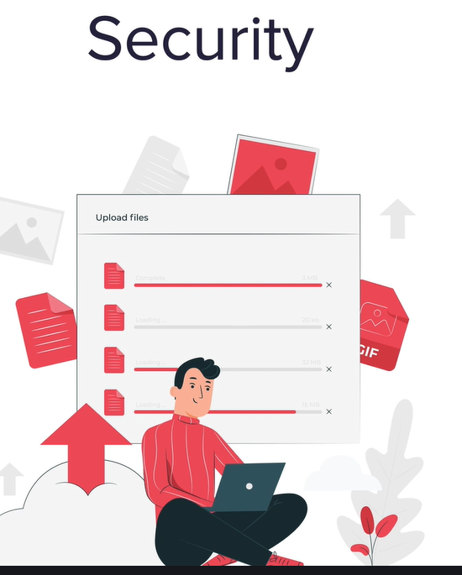

To create type export NAME=XXXXX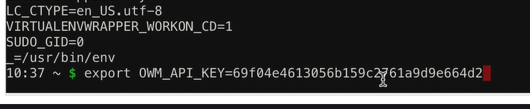

Then by running env will be able to see it and use it in code run from this location (in my case PyCharm)

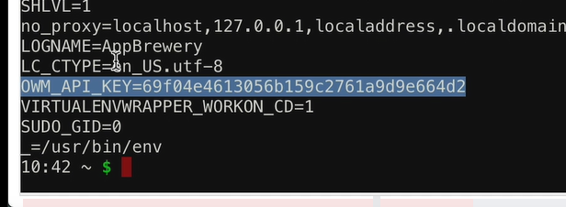

So in python anyhwhere it looks like this:

